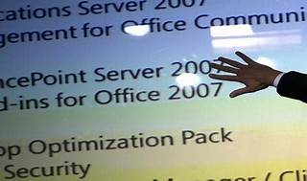

Explore

Certainly! **Microsoft Exchange** is an email service offered by Microsoft, commonly used by businesses and academic institutions. [It synchronizes email, contacts, calendars, and tasks between an Exchange server and client email apps like Microsoft Outlook1](https://www.businessinsider.com/guides/tech/what-is-microsoft-exchange)[2](https://www.techopedia.com/definition/19228/microsoft-exchange).

Here are **five free resources** where you can learn more about Microsoft Exchange:

1. [**Microsoft Learn Exchange Documentation**](https://learn.microsoft.com/en-us/exchange/): This comprehensive resource provides information for admins and IT professionals managing Exchange and Exchange Online.
2. [**Udemy Course: Exchange Server & Exchange Online**](https://www.udemy.com/course/exchange-server-exchange-online-course-with-hands-on-demos/): A hands-on course covering topics like creating a Microsoft 365 account, managing databases, and working with Exchange Online.
3. [**Practical 365 Training**](https://practical365.com/training/): Video-based training courses on Office 365 and Exchange Server deployment, configuration, and migration.
4. [**Udemy Course: Learn Microsoft Exchange Server**](https://www.udemy.com/course/learn-microsoft-exchange-server-beginner-to-master/): From basics to mastery, this course covers topics like email systems, Active Directory, and client access services.
5. [**Microsoft Learn: Managing Resource Mailboxes in Exchange Online**](https://learn.microsoft.com/en-us/exchange/recipients-in-exchange-online/manage-resource-mailboxes): Learn how to manage room mailboxes and other resources in your Exchange Online organization.

Feel free to explore these resources to enhance your understanding of Microsoft Exchange! 📧👩‍💻